Lab 5 Working with MS Access Forms LAB 6
Summary
- Creating Multiple-Table or Linked Forms
- Calculating Totals and Using Expressions
- Creating Pop-Up Forms, Custom Dialog Boxes, and Message Boxes
- Creating Switch Board Forms

- Relationship View of Northwind.mdb
As in the other sessions, we will use Northwind sample database. Reviewing relationship view of northwind.mdb will help you understand topics covered in this lab session.

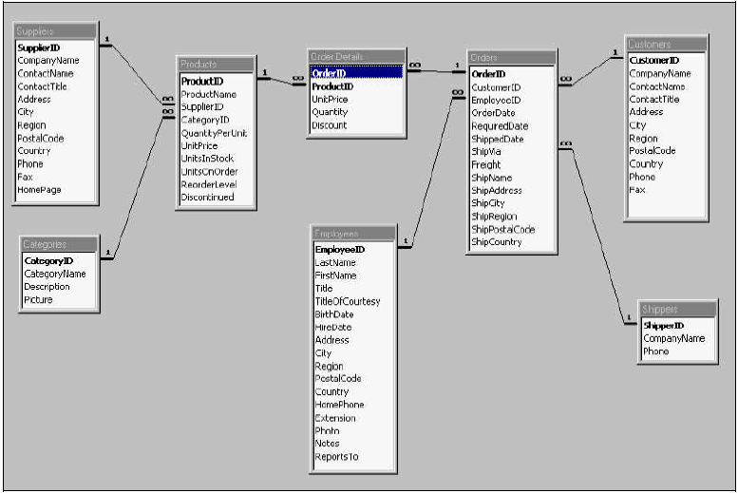
Fig. 1 Relationship View of Northwind.mdb

- Creating Multiple-Table or Linked Forms
Using a Form Wizard is the simplest and fastest way to create a form that brings data together from more than one table. A Form Wizard speeds up the process of creating a form because it does all the basic work for you. In the first screen of a Form Wizard, you can pick the fields you want to include in your form. These fields can be from one table or from multiple tables.

You can use a Form Wizard to create a form that displays data from multiple tables as a "flat form" or as a "hierarchical form." An example of a flat form is a form that shows products and product suppliers (See Fig. 2). A hierarchical form is a form with one or more subforms. Subforms are useful if you want to show data from tables that have a one-to-many relationship. For example, you could have a “Categories” form that includes data from a “Categories” table and a “Products” table (See Fig. 3). You may want to present your data hierarchically without using a subform. For example, if you have a form with lots of controls, you may not have room for a subform. In this case, you can use a Form Wizard to create synchronized forms (See Fig. 4). When you click a command button on one form, it opens another form that's synchronized with the record on the first form.

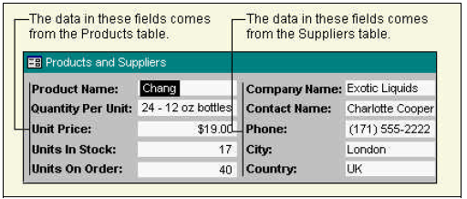
Fig. 2 Example of a multiple-table flat form

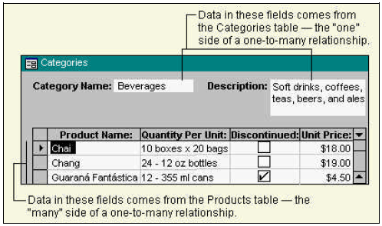
Fig. 3 Example of a multiple-table hierarchical form

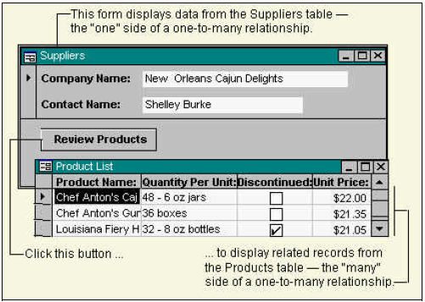
Fig. 4 Example of synchronized forms
  - Subforms
A subform is a form within a form. The primary form is called the main form, and the form within the form is called the subform. A form/subform combination is often referred to as a hierarchical form, a master/detail form, or a parent/child form.

Subforms are especially effective when you want to show data from tables or queries with a one-to-many relationship. For example in Fig. 5, you could create a form with a subform to show data from a Categories table and a “Products” table. The data in the “Categories” table is the "one" side of the relationship. The data in the “Products” table is the "many" side of the relationship-each category can have more than one product.
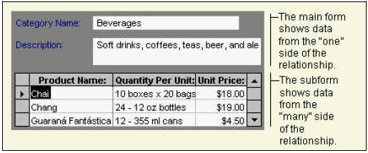
Fig. 5 Example of Form with a Subform

The main form and subform in this type of form are linked so that the subform displays only records that are related to the current record in the main form. For example, when the main form displays the “Beverages” category, the subform displays only the “Products” in the “Beverages” category. When you use a form with a subform to enter new records, Microsoft Access saves the current record in the main form when you enter the subform. This ensures that the records in the "many" table will have a record in the "one" table to relate to. It also automatically saves each record as you add it to the subform.

  - Creating a Form with a Subform
Before using this procedure, make sure you've set up your table relationships correctly.
- In any Microsoft Access main menu, click on InsertForm .
- In the New Form dialog box as shown in Fig. 6, double-click Form Wizard in the list.
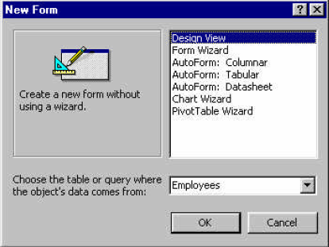
Fig. 6 New Form dialog box
- In the first wizard dialog box, select a table or query from the list. For example, to create a “Categories” form that displays “Products” for each category in a subform, select the “Categories” table (the "one" side of the one-to-many relationship).
- Double-click the fields you want to include from this table or query.
- In the same wizard dialog box, select another table or query from the list. Using the same example, select the “Products” table (the "many" side of the one-to-many relationship in the Categories form example).
Note It doesn't matter which table or query you choose first.
- Double-click the fields you want to include from this table or query.
- When you click Next, if you set up the relationships correctly before starting the wizard, the wizard asks which table or query you want to view by. Using the same example, to create the “Categories” form, click By Categories.
- In the same wizard dialog box, select the Form With Subform(s) option.
- Follow the directions in the remaining wizard dialog boxes. When you click Finish, Microsoft Access creates two forms, one for the main form and subform control, and one for the subform.

  - Example of a Form with Subform : “Orders”
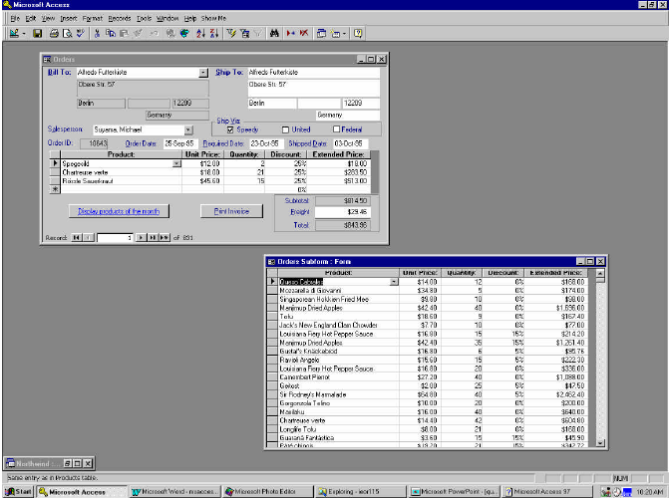
Fig. 7 “Orders” Form and Subform in Northwind Database

2.3.1 Overview of “Orders” Example
The “Orders” form is a main form with one subform. The main form, “Orders”, displays order information, which you can add, edit, or delete. It is bound to “Orders Qry” query, a hidden query. The “Orders” subform displays information about the products ordered, which you can also add, edit, or delete. It is bound to the “Order Details Extended” query.

2.3.2 Orders form
The “Orders” form uses expressions in the following controls:
- The Subtotal text box uses an expression in the ControlSource property to refer to the value of the OrderSubtotal text box on the Orders subform.
- The Total text box uses an expression to calculate the total for the order.
- The OrderDate text box uses Date function in the DefaultValue property to automatically fill in today's date.

The form uses the following settings in form and control properties:
- The form's Cycle property is set to Current Record so that the focus stays on the current record in the form rather than automatically advancing to the next record. You can use the navigation buttons to switch to a different record.
- The HyperlinkAddress property of the DisplayProducts command button is set to Products.doc, a Microsoft Word document. The document opens in Word when you click the command button.
- The ControlTipText property the CustomerID combo box specifies a tip that is displayed for the control in Form view when the mouse pointer rests on the combo box.

The form uses event procedures in the following properties:
- The event procedure in the BeforeUpdate property of the CustomerID combo box displays a message if you leave the combo box without adding a value.
- The event procedure in the AfterUpdate property of the CustomerID combo box sets the values of the controls in the Ship To area of the form to the values of their corresponding controls in the Bill To area of the form.
- The event procedure in the OnClick property of the PrintInvoice command button prints the “Invoice” report for the current record. (specify the select query as the filtername argument of the OpenReport method.)

2.3.3 Orders Subform
- The OrderSubtotal text box uses the Sum function in an expression to calculate the subtotal for the order.
The form uses event procedures in the following properties:
- The event procedure in the OnError property of the form displays a message and undoes any records entered in the subform if the BillTo combo box on the Orders form doesn't have a value.
- The event procedure in the AfterUpdate property of the ProductID combo box fills in the UnitPrice value for the selected product.
- Event procedures in the BeforeDelConfirm and BeforeUpdate properties of the form and in the BeforeUpdate property of the ProductID combo box display a message and undo changes if you open the subform as a standalone form and attempt to add, change, or delete records.

- Calculating Totals and Using Expressions:
Please follow the procedure as below:
- Open a form in Design view (or a report in Design view).
- Click the tool in the toolbox for the type of control you want to use as the calculated control. For further information on toolbox, please refer to Fig. 8.
Note: A text box is the most common type of control to use to display a calculated value, but you can use any control that has a ControlSource property.
- On the form, click where you want to place the control.
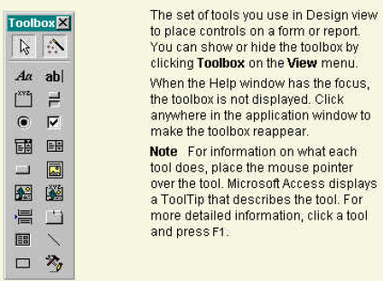
Fig. 8 Toolbox

- Do one of the following:
  - If the control is a text box, you can type the expression directly in the control.
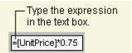
  - If the control isn't a text box, or if the control is a text box but you want to use the Expression Builder to create the expression, make sure the control is selected. To select a control, click it.
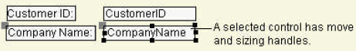
Then click Properties on the toolbar to open the control's property sheet, and then type the expression in the ControlSource property box or click the Build button to open the Expression Builder.

Table 1 shows some examples of performing arithmetic operations in forms and reports.

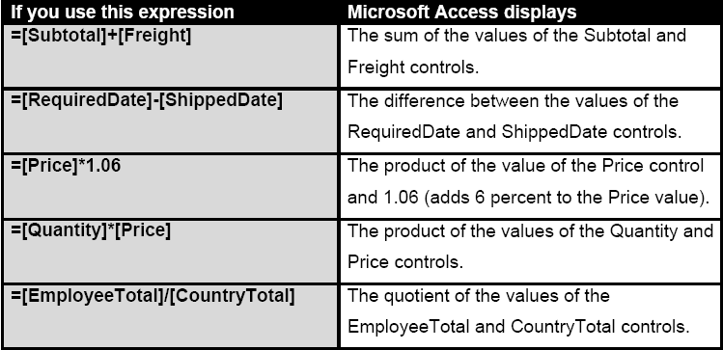

Table 1 Example of Expressions
- Creating a pop-up form or custom dialog box
You can create a pop-up form to display information to a user or to prompt a user for data. A pop-up form stays on top of other open forms, even when another form is active. A pop-up form can be modeless or modal. When a pop-up form is modeless, you can access other objects and menu commands while the form is open. For example, on an “Orders” form, you could add a command button that displays a “Products” pop-up form. The pop-up form displays information about a product in the “Orders” form. Go back to Fig. 4 for the example of pop-up form.

Create a pop-up form
- Create the form. The form can include any combination of controls.
- In form Design view, double-click the form selector to open the property sheet for the form.
The form selector as shown in Fig. 9 is the box where the rulers meet in form Design view. Click this box to select the form. Double-click this box to open the form's property sheet.
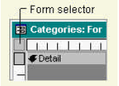
Fig. 9 Form Selector

- In the PopUp property box (under Other tab or All tab), click Yes.
- In the BorderStyle property box (under Format tab or All tab), click Thin if you don't want the form to be sizable; otherwise, skip to the next step. If you select the Thin setting, you can move the pop-up form, but you can't size it.
- Create a macro or event procedure that opens the form.
Note: To see an example of an event procedure that displays a modeless pop-up form, go to the form Suppliers in Northwind database, open the properties of the command button Review Products, and then click the Build button next to the OnClick property box. Refer to Fig. 10.
- Attach the macro or event procedure to a form or report by specifying the macro name or event procedure as the setting for the appropriate event property. For example, type the name of the macro or event procedure in the OnClick property box of a command button.

- Switch Board Forms
When you use the Database Wizard to create a database, Microsoft Access automatically creates a switchboard that helps you to navigate around the database. This switchboard has buttons that you can click to open forms and reports (or open other switchboards that open additional forms and reports), quit Microsoft Access, or customize the switchboard. See Fig. 11 for an example. You can create a switchboard similar to the one that the Database Wizard creates by using the Switchboard Manager.
Create a switchboard form by using the Switchboard Manager
When you use the Database Wizard to create a database, the wizard creates a switchboard that makes it easy to navigate between the forms and reports in your database. If you want to build the same type of switchboard for a database you created yourself, you can use the Switchboard Manager.
- On the Tools menu, point to Add-ins, and then click Switchboard Manager.
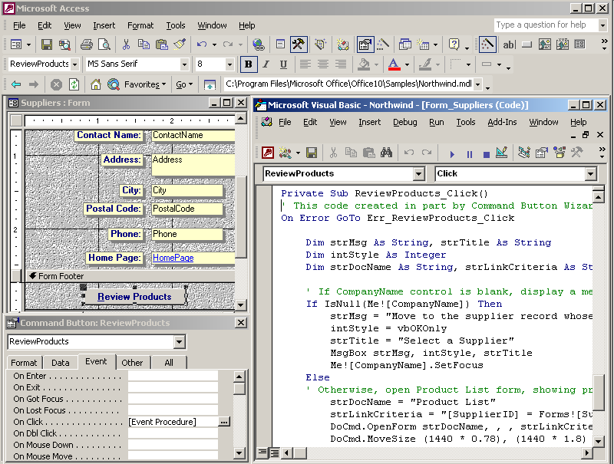
Fig. 10 Popup Event Procedure Example in Northwind
- If Microsoft Access asks if you'd like to create a switchboard, click Yes.
- In the Switchboard Manager dialog box, click Edit.
- In the Edit Switchboard Page dialog box, type a name for the switchboard in the Switchboard Name box, and then click New.
- In the Edit Switchboard Item dialog box, type the text for the first switchboard button in the Text box, and then click a command in the Command box. For example, type Review Products in the Text box, and then click Open Form In Edit Mode in the Command box.
- Depending on which command you click, Microsoft Access displays another box below the Command box. Click an item in this box, if necessary. For example, if you clicked Open Form In Edit Mode in the Command box in step 5, click the name of the form you want to open in the Form box, such as Review Products, and then click OK.
- Repeat steps 4 through 6 until you've added all the items to the switchboard. If you want to edit or delete an item, click the item in the Items On This Switchboard box, and then click Edit or Delete. If you want to rearrange items, click the item in the box, and then click Move Up or Move Down. Click Close then.
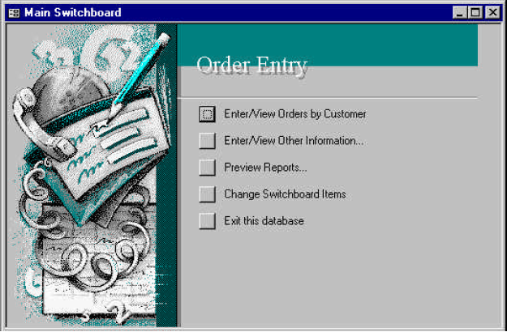
Fig. 11: Example of Switch Board Form

Quiz 5
(Due at the start of next class)
You need to use car.mdb for this lab.

- Improve the design of one of two forms in Quiz 4: inventory check-in form and customer tracking form.
- Create a form which serves as the switchboard by allowing the user to easily access the forms and report you built before. Use Access help if you have questions on how to create a switchboard form.

Further instructions:
For the quiz, please provide:
- Screenshot for the form you created. Also please include a screenshot of the original one from quiz 4 for comparison and describe concisely where you made the improvement.

To do a screenshot capture, open the window which you want to capture, maximize it (or size it appropriately) and the do Alt+Print Screen. Then just do a Paste command in your word processing software to import the image into your document.

Control is a graphical object, such as a text box , a check box , a command button , or a rectangle , that you place on a form or report in Design view to display data, perform an action, or make the form or report easier to read.
Macro is an action or a set of actions you can use to automate tasks.
Event procedure is a procedure automatically executed in response to an event initiated by the user or program code, or triggered by the system.

